QF600 Asset Pricing Assignment3

ChanJung Kim

November 14, 2018

Part 1: Performance Measurement

1. Sharpe Ratio

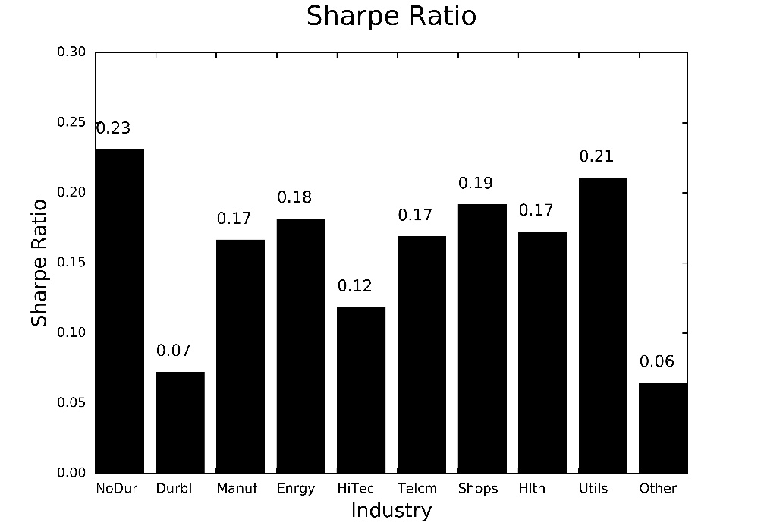

The Sharpe ratio measures the excessive return over risk-free rate per unit of standard deviation. By subtracting risk-free rate from the mean return, we can tear off the profits from risk-taking activities. The denominator of the ratio captures not only systematic risk, but idiosyncratic risk. The Sharpe ratio is significant in that it contains both risk and return within a simple measure. However, the Sharpe ratio may oversimplify risk, ignoring skewness and kurtosis of the return distribution.

1. Sortino Ratio

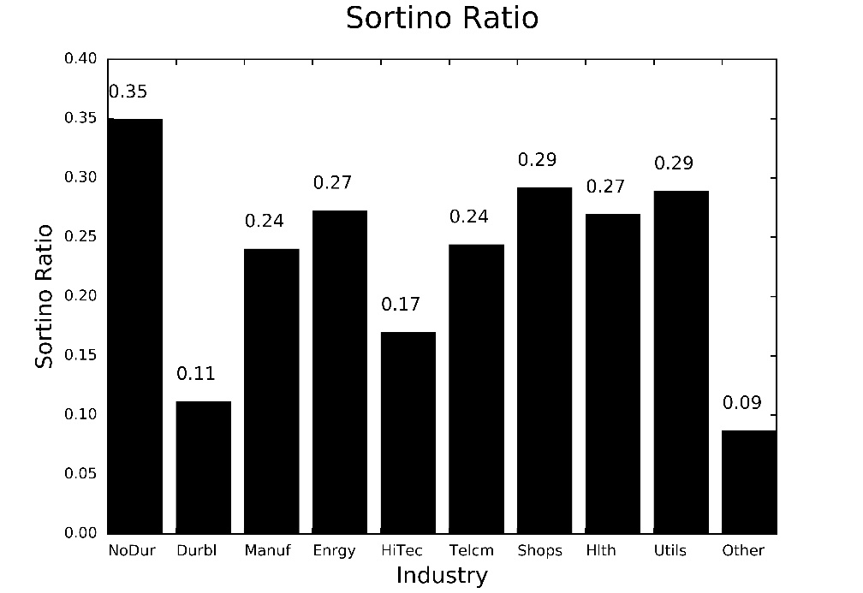

The Sortino ratio is another indicator to measure the risk-adjusted return of an investment asset. It is a modification of Sharpe ratio that penalizes only harmful volatilities. The Sortino ratio uses below-target semi-deviation as its denominator instead of standard deviation. This approach enables the Sortino ratio to reflect skewness of the return.

1. 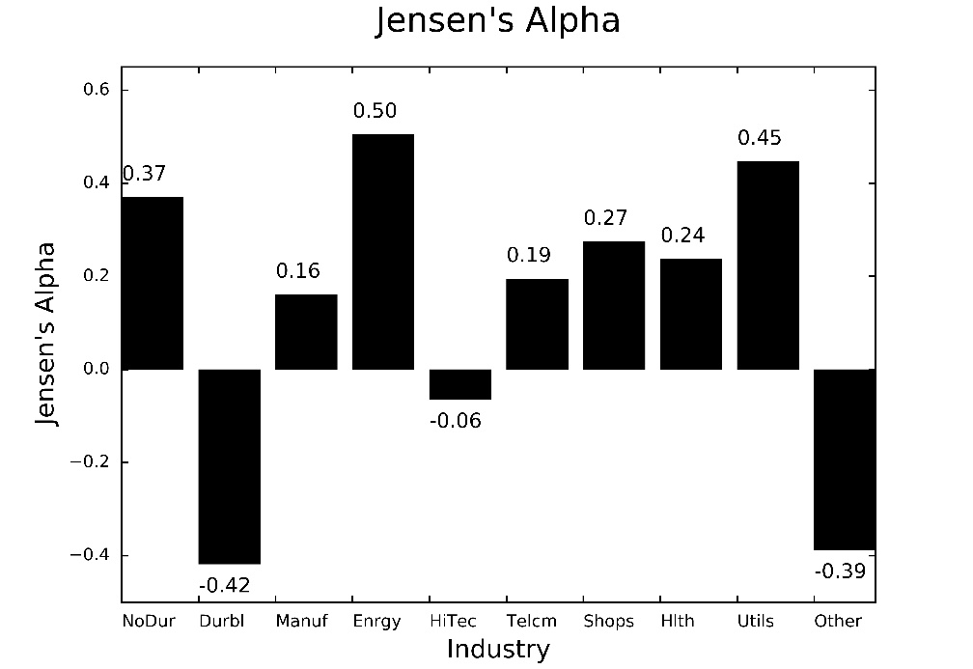Jensen’s Alpha

Jensen’s alpha is equivalent to the intercept coefficient of CAPM. On top of the previous two measures, Jensen’s alpha is also one of the measures considering return and risk at the same time. For a passive portfolio, Jensen’s alpha denotes pricing error of CAPM, while in an actively managed portfolio, it means the manager’s ability to create additional value.

1. 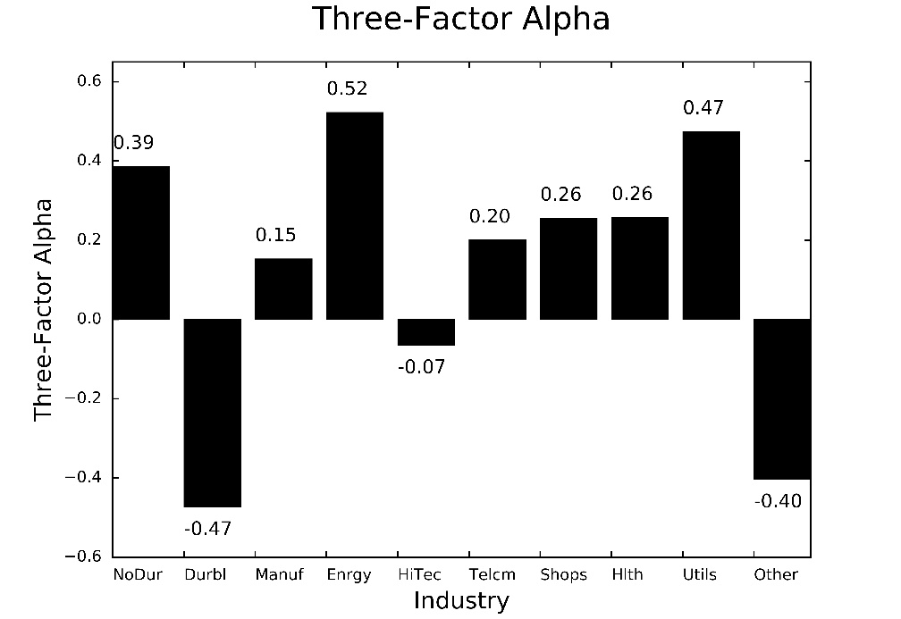Three-Factor Alpha

Fama-French three-factor model was designed to better reflect the return of an investment asset than the CAPM does. Even though the CAPM is easy to understand, and has solid theoretical background, empirical research revealed that the CAPM couldn’t capture various systematic pricing anomalies. To overcome the limitation of the CAPM, two more factors - the outperformance of small versus big companies, and the outperformance of high book/market versus small book/market companies – were added to the CAPM. Three-factor alpha is the intercept coefficient of Fama-French three-factor model. Three-factor alpha can be interpreted similarly with the Jensen’s alpha.

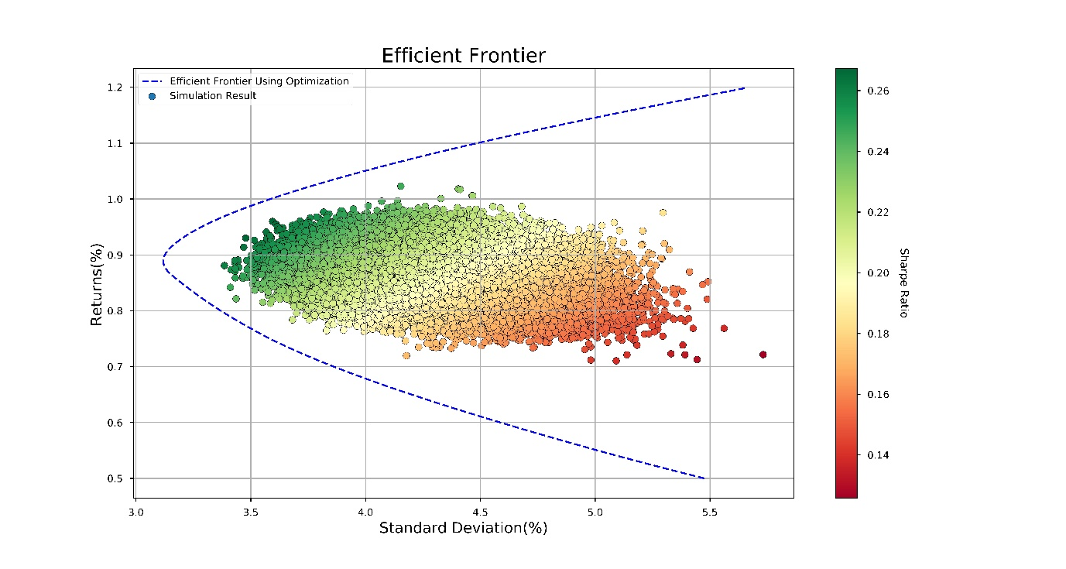Part 2: Minimum-Variance Frontier

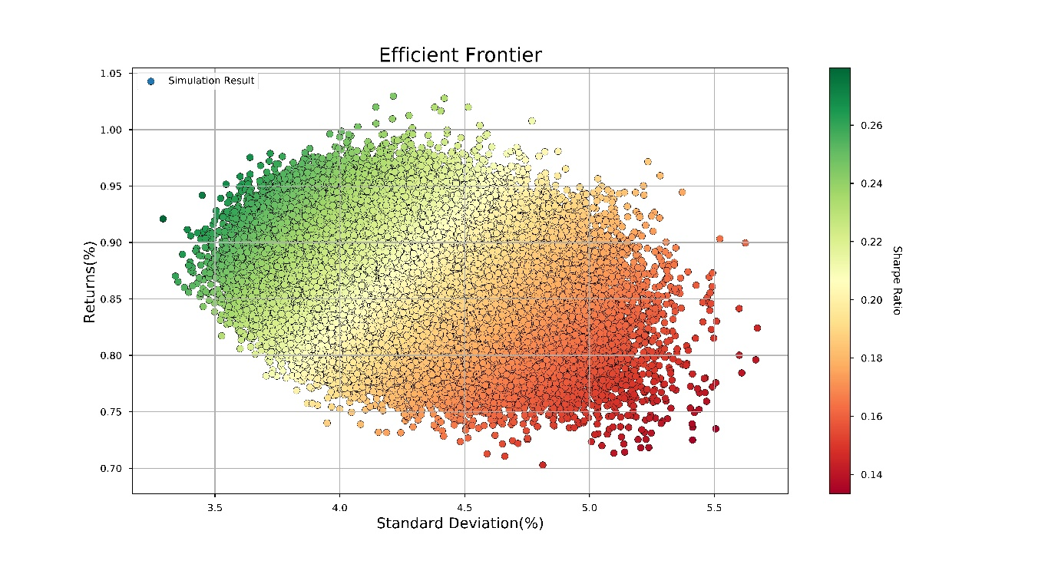

Figure 1 Monte-Carlo simulation result with optimized efficient frontier

Figure 2 Monte-Carlo simulation result when the number of iteration is 250,000

The Figure 1 is a simulation result when the number of iteration is 250,000. In the Figure 2, optimized efficient frontier is added to figure out how good the simulation result is. The simulation result, however, couldn’t reach out enough to meet the efficient frontier.

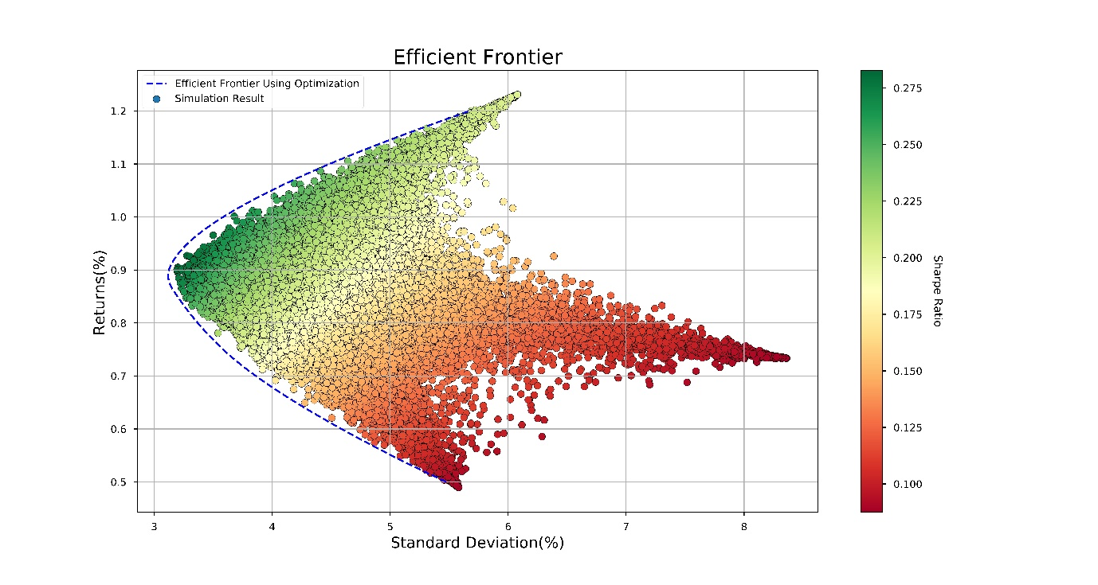

Figure 3 Monte Carlo Simulation with the inversed weight

To get the desired result easily, I tried inversing the weight vector of each industry. In this case, simulated portfolios were formed along with the efficient frontier.

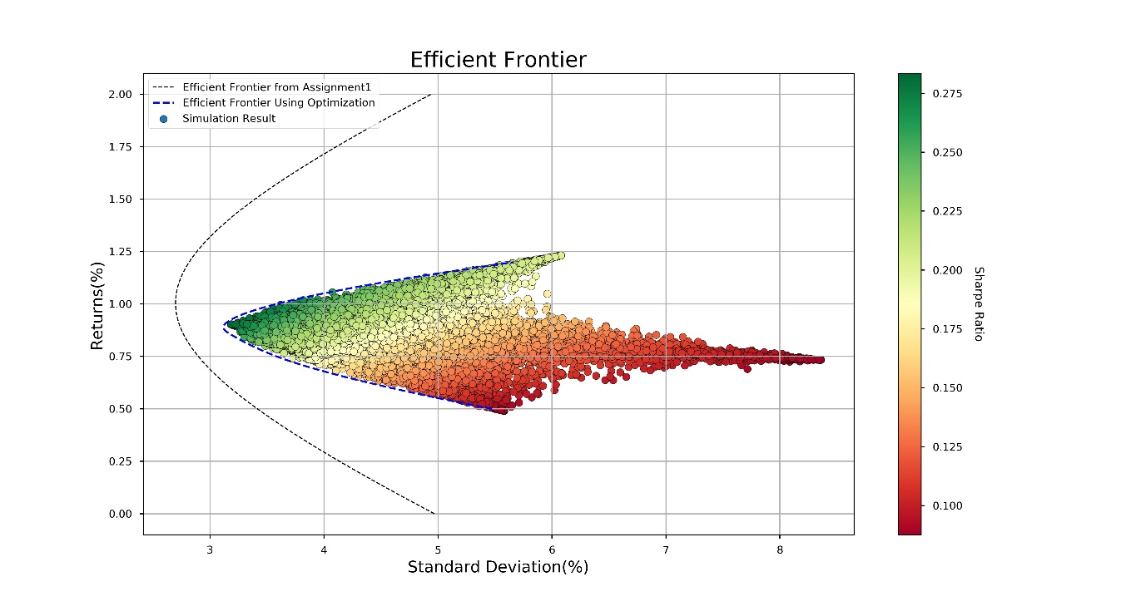

Lastly when the efficient frontier from the first assignment was added in the same figure, it was much bigger than the optimized frontier created under the restriction of short sales. This is because the efficient frontier from the first assignment allows taking a short position on the industry portfolio, increasing the area of the possible investment options.